International Journal of Health Medicine and Current Research
Vol. 2, Issue 01, pp.264-268, March, 2017

INTERNATIONAL JOURNAL OF HEALTH MEDICINE AND CURRENT RESEARCH
DOI:
10.22301/IJHMCR.2528-3189.264
Article can be accessed online on:
http://www.ijhmcr.com

ORIGINAL ARTICLE

THE EFFECTIVENESS OF COUNSELING AND SUPPLYING OF PEROXIDE (RICE) CONTROL MATERIAL AT THE SELLERS OF FRIED FOODS IN MANADO OF NORTH SULAWESI

Agus Rokot, Agnes Watung, Anselmus Kabuhung

1 Poltekkes Kemenkes Manado, North Sulawesi, Indonesia

ARTICLE INFO ABSTRACT

Article History:
Received 17th January, 2017 Received in revised form 18th February, 2017 Accepted 20th March, 2017
Published online 30th March, 2017

Key words:
Counseling Control Material (Rice), Oil Fried, Peroxide Levels.

*Correspondence to Author:
Agus Rokot
Poltekkes Kemenkes Manado, North Sulawesi, Indonesia

E-mail:
agus₋rokot@yahoo.com
Research aims to understand the effectiveness of counseling and the provision of control material peroxide (rice) to food fried sold traders fried in manado .Research methodology used is survey analytic .Data collection through the direct he then examination in the laboratory to get levels peroxide on oil fried
. The analysis using analysis difference of two the average (test t test).Population affordable 192 traders fried, the sample collection early 65 traders, counseling, and recovery the end is 65 traders fried.The research results show : 1) there was a correlation the use of oil fried is constantly being against elevated levels of peroxide on oil fried , 2) there was a correlation level the effectiveness of counseling and the provision of control material peroxide to a decrease in the peroxide on oil the results of fried . t_{hit} 1,410 < t_{tab} 1,671 . 3) peroxide levels of the womb before it was given counseling 0,376873meq/kg , after counseling and the provision of controller peroxide ( rice ) become 0,298737 meq/kg, or a decrease of 0,078136meq/kg on oil fried-snack vendor who used traders, 4) the measurement result levels peroxide on oil the results of fried, than 65 sample early that exceeds the threshold 2 meq/kg such as 1 sample no. Sample 47, of 3,007520meq/kg. Implication counseling and the provision of control material peroxide was an effective way to lower levels of peroxide which is in oil fried which must be known by traders fried and people consume fried to avoid from risks for the health.

Copyright © 2017, Agus Rokot. This is an open access article distributed under the creative commons attribution License, which permits unrestricted use, distribution, and reproduction in any medium, provided the original work is properly cited.

Citation: Agus Rokot, Agnes Watung, Anselmus Kabuhung, 2017 “The Effectiveness Of Counseling And Supplying Of Peroxide (Rice) Control Material At The Sellers Of Fried Foods In Manado Of North Sulawesi”, International Journal of Health Medicine and Current Research, 2, (01), 264-268.

INTRODUCTION

Food was important component of human live, that hoped running the precise and right metabolism so that human were healthy and doing activities well. The effort of being health was always done by every person, but sometimes, at the situation and condition, we were willfully of not, had consumed fast foods that served by the sellers without thinking of the effect for our health. This was defined by the researcher that fast foods in the type of fried foods in Manado which used oil many times for some fried, considering that cooking oil would be going damage when getting many times heating, contact with water, air, and metal. The damage of cooking oil during frying process were through the stages of oxidation, polymeration, and hydrolysis where the damage cooking oil while frying process would form undesirable compound such as polymer, free fat acid, peroxide, and other waste which was getting suspension in the oil. (Wulyoadi dan kaseno,2004)
There were some reasons of using cooking oil for many times, it might the users knew or didn’t know about it’s consequences or effects for health, or it migt be related with economic factor for the profit desired so that ignored the health value, or there was less of control from the government toward the sellers who sold the foods at the societies, or it might that the sellers was less of knowledge about the fried changes such as: the change of peroxide compound and high free fat acid. This was also explained in the Indonesia National Standard (SNI)-3741-1995 which gave limits toward the rate of dangerous peroxide of 2mEq/kg, the using of fried food with high peroxide and fat acid would cause health problems for the consumers.
Based on the explanation above, the aims of this research was to know the peroxide content at cooking oil used by fried foods sellers in the sale centers of Malalayang Sub district, Malalayang, Wanea, Wenang, Tikala, paal ll, Singkil, Tuminting and Mapanget of Manado City of North Sulawesi with common physical characteristics such as: color, aroma, and frequency of frying. The proving of the existence of cooking oil with over limit peroxide (H₂O₂) was done by examining the cooking oil that had been used. Sample was taken for checking in the laboratory so it could be made the examination result that gave certain answer whether the cooking oil used by the fried food sellers was over the limit determined so it gave conclusion and explanation about the effect of peroxide at the food which was fried at the cooking oil with high peroxide that could bad effect for the societies’ health or users who consumed
those foods.
Referring to the explanation of research background, the research problem could be formulated as follow: How was the using of cooking oil that could improve the peroxide content, that could be danger for the societies if they consumed the foods sold in certain food points in Manado City of North Sulawesi in 2016, with the hypothesis of:
- There was any correlation of using cooking oil for many times with the change of oil’s color toward the increasing of peroxide in the fried food.
- There was effectiveness level of counseling and giving of peroxide (rice) control material toward the peroxide (H₂O₂) content of fried oil.

The aimed achieved was knowing the effectiveness level of counseling and giving the material of peroxide (rice) control in decreasing peroxide content at the fried oil used by food’s sellers in Manado City of North Sulawesi.

METHODS

Research with analytic survey by taking the beginning sample of cooking oil from the fried food sellers then the examination of peroxide content was done in the beginning sample, then it was done the counseling by giving the material of peroxide control. It was given opportunity for 3 weeks, then it was taken the second sample, then the peroxide content was examined in order to be compared with the first peroxide content.
The reached population which could be achievable in the dense points around the fried food sellers in the lively location were 192, while other sample of 65 sellers were spread in Malalayang sub district, Wanea, Wenang, Tikala, Paal ll,Singkil, Tuminting,Mapanget who commonly operated at the afternoon or at the night in Manado City of North Sulawesi Province.

RESULTS

Analysis of respondents characteristic who operated in selling the fried foods in Manado City that spread in some sub of: Malalayang, Wanea,Wenang,Tikala, Paal ll,Singkil, Tuminting dan Mapanget Kota Manado Propinsi Sulawesi Utara as follows:

- Respondents’ Distribution

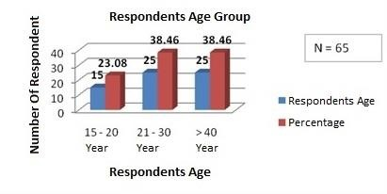
Figure 1. Respondents’ distribution based on the sellers’ age

Figure 1 explained that respondents’ distribution based on the age were: 21 to 30 years old were 25 respondents (38,46%) and group of age more than 40 years old were 25 respondents (38,46%) and the least respondents was by the age of 15 to 20 were 15 respondents (23,07%).

- The period of respondents sold the fried foods
The result of data analysis and tabulation for the distribution of respondents who sold the fried foods based on the period of selling were as follow: respondents with period less than 1 year were 3 persons (4,62%), 1 year were 17 persons (26,15%), 2 years were
7 persons (10,76%), 3 years were 5 persons (7,69%), 4 years were 5 persons (7,69%), and 5 years or more were 28 persons (43,07%). Respondents distribution based on the period of selling the fried foods could be seen in figure 2 below.
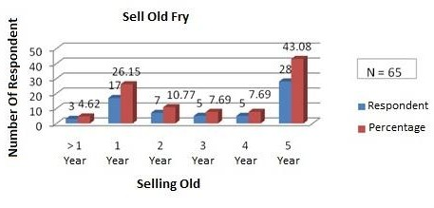
Figure 2. Period of sellers sold the fried foods

- Period of using cooking oil in the fried food
The data tabulation result for respondents who used cooking oil for frying with the longest time were respondents with time of 1 to 2 hours were 35 persons (53,85%), and respondents with time of 3 to 4 hours were 25 persons (38,46%), and respondents with time more than 4 hours were 5 persons (7,69%). Respondents distribution based on the period of using
cooking oil in frying process could be seen in the figure 3 below.
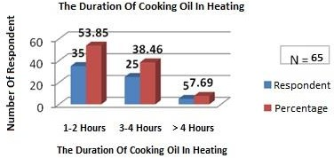

Figure 3. Period of Cooking Oil in the Frying Process

- Source of Heating used in Frying Process
The result of data analysis and tabulation for the respondents distribution based on the heating source used in frying process were as follow: respondents who used firewood was 1 person (1,54%), used kerosene was 1 person (1,54%), and the most were they who used gas stove were 63 persons (96,92%). The respondents distribution based on the heating tools used in frying process could be seen in the figure 4 below.

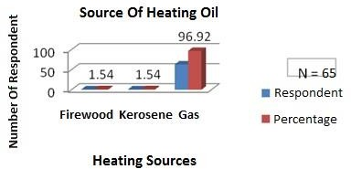

Figure 4. Heating Source of Frying Process

- Oil Color in the Frying
The color of cooking oil before being used was commonly clear yellow till light yellow. But, the sampling of oil that had been used in the frying period with the target of banana, tofu, tempe, Malabar, cassava, and others that related with food sold in the societies in sample points of sellers who sold in area sub districts of Malalayang, Wanea, Wenang, Tikala, Paal ll, Singkil, Tuminting, Mapanget showed the detail color of samples taken as follow: light yellow were 26 (40%), light brown were 19 (29,23%), dark brown were 17 (26,15%), black were 3 (4,52%) respondents. Distribution based on color of beginning sample could be seen in the figure 5 below.

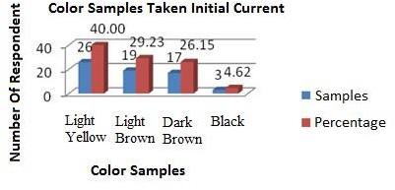
Figure 5. Color of Sample at the Beginning

- Sub districts Area of Sampling
The result of data analysis and tabulation by univariate for the respondents distribution based on the sub district area of selling were: in Malalayang were 12 persons (18,46%), in Wanea were 7 persons (10,77%), in
Wenang were 5 persons (7,69%), in Tikalah were 4 persons (6,15%), in Paal ll were 14 persons (21,54%), in Singkil were 13 persons (20,00%), in Tuminting were 4 persons (6,15%), and in Mapanget were 6 persons (9,23%). The respondents distribution based on sub districts area of fried food selling could be seen in figure 6 below.

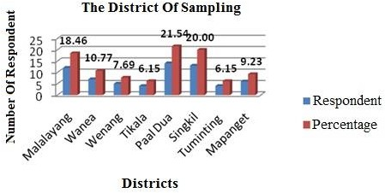
Figure 6. Sub districts Area of Sampling

Result of Statistic Test
Analysis result of statistic test of difference of two averages with dependent sample, with explanation of dependent sample according to Kadir (2010:98) stated that: dependent sample was sample that it’s existence was influenced each other (correlated). The distribution of both sample data couldn’t be convinced of not independent but rationally or theoretically they were correlated. The essence of analysis of difference of two averages of dependent sample was both data that would be examined was it’s difference that came from one group of sample (one analysis unit) which resulted two data distribution.

DISCUSSION
  - There was correlation of effectiveness level of counseling about peroxide control toward the decreasing of peroxide content at the cooking oil ised by fried food sellers with the comparison of (t_{hit} 1,410˂ t _{tab} 1,671)
  - The research result based on the respondents’ age group showed that they were productive ages in finding and creating job vacancy. But in one side, the profession of selling fried food that related to fried result needed to get attention from the government, especially from health officers and related instance for the monitoring of peroxide limit permitted in health condition so that the people who consumed the foods were out of risk.
  - The period of selling the fried foods was positive thing to help food supplying needed. But, it needed to be highlighted the time and period of using cooking oil because by the longer time in frying process, the quality of the oil would be changed even could cause the increasing of peroxide content in the frying process.
  - Heating source used could determine the quality of the fried oil because generally the heating used was gas stove, where the heating level of gas stove was high enough compared with heating by using fire wood and kerosene so that it needed paying attention to the heating source used in order to avoid the burnt and increasing of peroxide inside.
  - Sub districts area used as research samples, generally, had been in the representative position because most of those area in Manado city had been sampled at the beginning and counseling about the peroxide prevention by the health officers (health students of employees’ class) who had been trained in the field of monitoring process related to the health, moreover they were helped by the environment health students who were studying about environment problems.
  - Statistic test result had explained that there was influence or effectiveness of counseling in decreasing peroxide content of fried oil used by the fried food sellers. By doing the counseling, the decreasing level of peroxide was very significant where the quality of cooking oil used was increasing and the peroxide content was decreasing and even it could avoid the societies from the diseases when they consumed the fried food.

CONCLUSION

    - Respondents with the age of more than 40 years old placed in the highest position could understand the input of how to avoid peroxide content and how to increase the quality of cooking oil. This could be proven that appropriate with the result that there was tendency of decreasing of peroxide content.
    - According to this research, basically, during the time the fried food sellers sold their products, they hadn’t known much about specific counseling related to peroxide content from health side which could influence the consumers. .
    - Period of cooking oil in the frying process until 4 hours or more could describe the damage level of the oil and peroxide content inside it.
    - According to this research, previously, the sellers were observed and then health officers took the beginning sampling. After that, they gave counseling about the effect of peroxide increasing in the fried oil, moreover they gave solution to avoid peroxide content in the oil.
    - Test result explained that there was influence counseling related to the decreasing of peroxide content before and after counseling compared with standard determined by the government, it was under the limits of 2mEq/kg.

Suggestions
- Avoid long period of frying process because it could stimulate the increasing of peroxide content of cooking oil.
- It hoped that when using gas as heating source could manage the ignition because gas had heat level that higher than firewood and kerosene.
- Color of cooking oil could give indication of peroxide content that was appropriate with level of beginning monitoring from high to low with the color: blackish, dark brown, light brown, and light yellow.
- It needed to give counseling for the sellers by the health officers about the effect of long frying period because it could stimulate the increasing of peroxide content which risked for consumers’ health.
- The policy makers, in this case were health instance for monitoring of standard limit, government for the orderliness and delegation of license, and security for maximizing the consequence if the sellers didn’t obey the rules determined in order to get healthy live for Manado people.

REFERENCES

- Achmad, Hiskia Lubna Baradja, Demonstrasi Kimia. Bandung: Nuansa Cendekia; 2015.
- Creswell, John W. Research Design Pendekatan kualitatif, kantitatif dan Mixed. Yogyakarta: Pustaka pelajar; 2010.
- Cahya dkk, Sifat Fisik Kimia dan Organoleptik Pasta Santan – Jurnal Pangan dan Agroindustri 2014; 2(4): 249-258.
- Dwi, Puspitasari Indarini, Kimia Analitik Dasar dengan strategi problem solving dan opend Experiment, Alfabeta, Bandung.
- Hom, M. Membuat Reagen kimia, Jakarta: Bumi aksara; 2006.
- Kadir, Statistika untuk penerapan ilmu-ilmu social, Jakarta: Rosemata sempurna; 2010.
- Lestari, F. Bahaya Kimia, Jakarta:EGC; 2010.
- Mulasari, Utami, Kandungan peroksida pada minyak goreng di pedagang makanan gorengan disepanjang jalan Prof. DR. Soepomo Umbulharjo, Jogjakarta:2012.
- Petrucci, Dkk. Kimia Dasar. Jakarta: Erlangga; 2007.
- Riduwan, Sunarto H. Pengantar Statistika untuk penelitian social, ekonomi, komunikasi dan bisnis. Bandung: Alfabeta; 2009.
- Sukardjo, Kimia Anorganik, Jogjakarta: Bina Aksara; 1994.
- Wulyoadi dan Kaseno Pemurnian minyak goreng bekas dengan menggunakan filter membrane. Prosiding seminar nasional Rekayasa kimia dan proses ISSN: 1411-4216. Semarang: Jurusan teknik Kimia fakultas teknik.Universitas Diponegoro; 2004.

********

